Polo Details
- HRCAV TTT Show 2019 logo
- 100% Polyester, 160gsm pique knit fabric
- Podium Cool™ moisture wicking fabric designed to help keep you cool and dry
- Ladies style features the JB’s placket in a distinctly stylish 1-button design
- Straight hem with side splits
- Easy care fabric, Quick drying
- Complies with standard AS/NZS 4399:1996 and AS/NZS 4399:2017 for UPF protection
Sizing
Available in Ladies and Unisex. For measurements see chart.
Ladies:
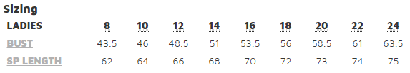
Unisex:
